"A Voyage to Space: China’s Manned Space Expedition" Special Exhibition Activity Sheet
(Secondary Level)
Since its inception, China’s Manned Space Program has made remarkable strides in a number of manned spaceflights, in-orbit astronaut stays and the construction of a space station. This exhibition showcases the journey of astronauts from training to their missions aboard the Tiangong Space Station. It also highlights their work and achievements in conducting scientific experiments on the space station and performing extravehicular activities. Let’s delve into the fascinating journey of astronauts on "Tiangong"!
Becoming an Astronaut
To prepare for the complex and dangerous tasks performed in the extreme environment of space, astronauts must undergo long-term and rigorous training. Experience astronaut training programmes at the "Becoming an Astronaut" exhibition zone, and answer the questions below.

Answer:
- What year marked the official launch of China's Manned Space Program?

The digital panel of "Complete Training Log of Astronauts" and text panel of "A Taste of Weightlessness" introduce information on how Chinese astronauts are trained. Fill in the blanks below with the correct answers.
2) Chinese astronauts are required to receive training programmes in four phases. Please list them below:
Basic Training

3) Why is it necessary for astronauts to have underwater training in a neutral buoyancy pool? (Refer to the information provided on the exhibit panel and explain it in your own words.)

Tiangong Space Station
Operating approximately 400 kilometres above the Earth’s surface, the Tiangong Space Station not only serves as a home to the astronauts but also as a space scientific laboratory.
4) The Tiangong Space Station can be flexibly assembled in-orbit like building blocks. Observe the space station model displayed at "Docking with Tiangong" section, then match the name of the modules and spacecraft by putting the corresponding letters into the boxes below.
A) Tianhe Core Module  It serves as the control and management centre of the space station, and the main living space for astronauts | B) Wentian Lab Module  It equips with multiple scientific experiment racks and features the main exit-entry point for astronauts to perform extravehicular activities. |  | C) Mengtian Lab Module  It consists of multiple scientific experiment racks and features exposure payload platforms that enable the exposure of experimental specimens to the space environment
D) Shenzhou Manned Spacecraft  It can accommodate and carry three astronauts to and from the space station |  | E) Tianzhou Cargo Spacecraft  It is an unmanned spacecraft which delivers supplies, such as food, maintenance parts, and propellants to the space station
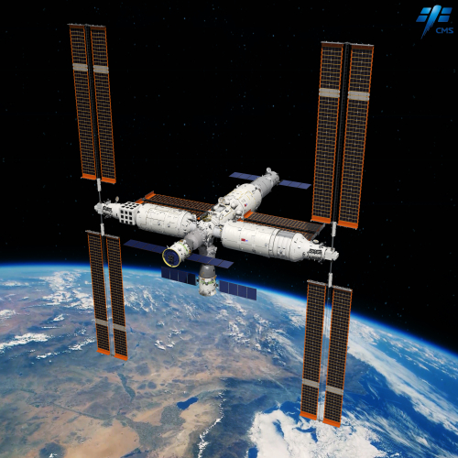

*Extended Thinking: What is the purpose of installing multiple sets of large solar panels to the Tiangong Space Station?

5) Go explore the "Infinity and Beyond" exhibition zone to learn about the planarian experiment in space, then complete the following questions.
a) Why did the scientists conduct the planarian experiment in space?

b) Use the microscope to observe the planarian specimen. Then, refer to the panel text and fill in the boxes below with the body parts of the planarian.

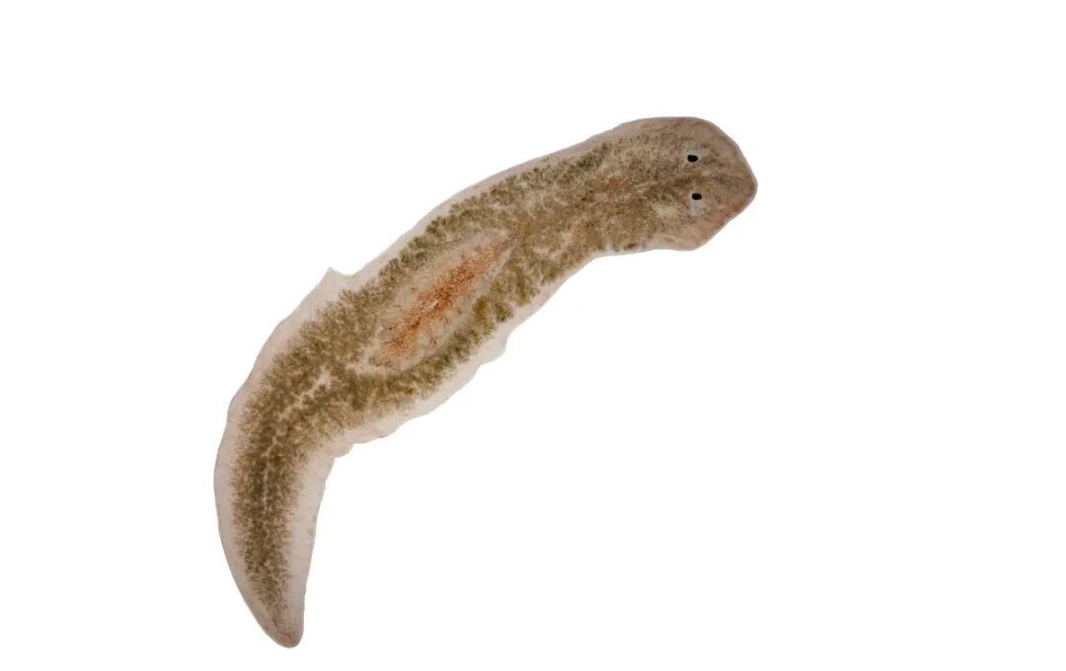

6) Go explore the "Tiangong Aquarium" exhibition zone to learn about the zebrafish experiment in space, and complete the following questions.
a) Zebrafish were sent to the Tiangong Space Station by the Shenzhou-18 and Shenzhou- spacecraft for research. They share over % genetic similarity with humans, making them widely used in biomedical research.
b) Why were the zebrafish being raised together with hornworts (aquatic plants) in a specially designed "space aquarium".
Hornworts can perform photosynthesis under lighting to provide to zebrafish. The plants also absorb the produced by zebrafish during respiration, as well as purifying the water by absorbing and breaking down the zebrafish .
c) Humans experience a disorienting sensation of weightlessness in space. What kinds of abnormal behaviours did the zebrafish exhibit when they swam in the weightless environment of space?

7) Go explore the “Horticulture in Tiangong" exhibition zone to learn how astronauts grow fruits and vegetables in space. Then complete the following questions.
a) Which of the following is/are the reason(s) for astronauts growing fruits and vegetables aboard the Tiangong Space Station?

A) As food
C) For relieving astronauts' psychological stress
B) For air purification
D) All of the above
Answer:

b) Plants will lose their direction under the weightless environment in space, making their stems and roots to grow in all directions. How did scientists guide the plants to grow in an orderly manner on the space station?

*Extended Thinking: Why is planting fruits and vegetables in space important for long-term space missions?
Spacewalks
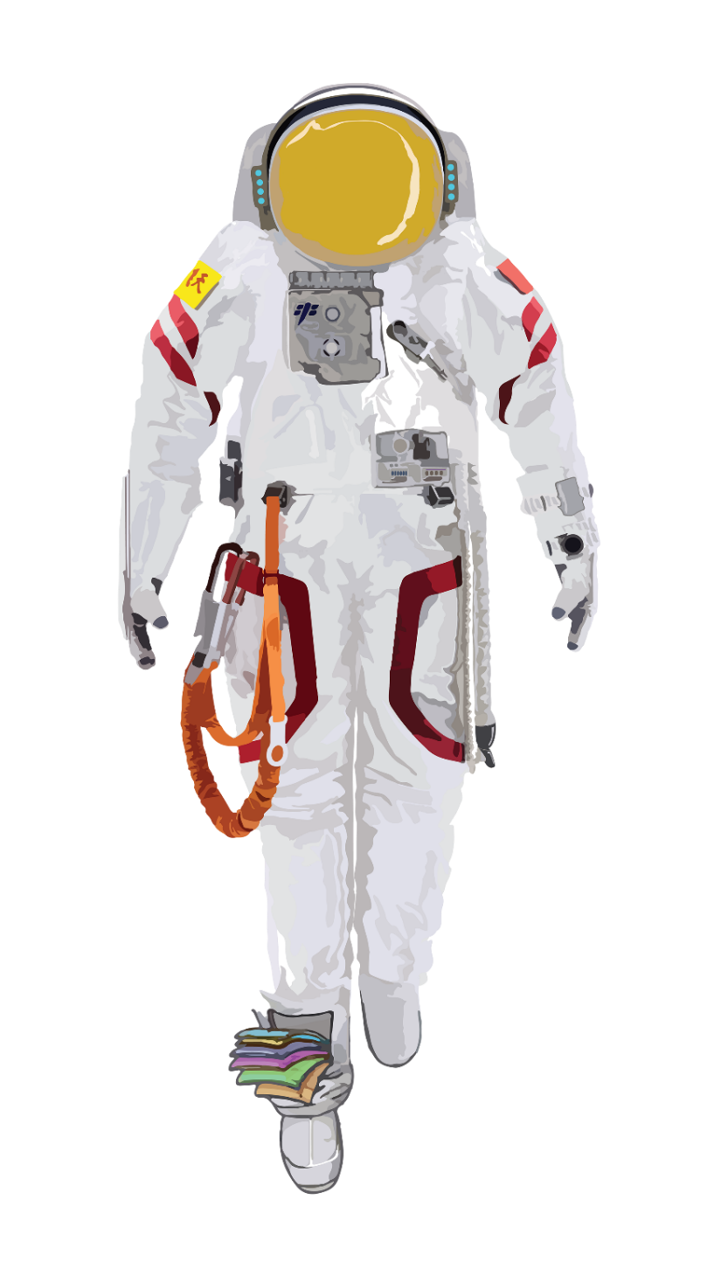
8) To cope with the harsh environment of space, Chinese astronauts will put on the "Feitian" extravehicular spacesuits when stepping out of the space station for extravehicular missions. Try look for the functions of different parts of the extravehicular spacesuit from the text panel.
Helmet Visor
__________________________________________ _____________________
_____________________
_____________________
The Mirror
on the Gloves
__________________________________________ _____________________
_____________________
_____________________
Electrical Umbilical
__________________________________________ _____________________
_____________________
_____________________

Safety Tether
__________________________________________ _______________________________________________________________
Electrical
Control Panel __________________________________________ _______________________________________________________________
Backpack
__________________________________________ _______________________________________________________________

9) Reflection and Summary
Complete the following reflections based on your visit and learning experience today:
1. My most interesting finding of today:
___________________________________________________________________________
2. Two aspects of space experiment that I think are significant to humans:

___________________________________
___________________________________

3. New insights I gained about the work of Chinese astronauts:
___________________________________________________________________________

